PROTON – Growth School Capstone Case Study
Proton AG – Product Strategy 2
Problem Statement 2
Project - 2
Why Privacy is important? 3
Examples of Privacy Threats 3
1. Market and user Research 4
2. Customer and Needs 6
2.1 Market Evolution 6
2.2 Customer Segmentation 6
2.3 New Avenues for Proton: Addressing Immediate Needs 7
3. Industry and Competitive Analysis 8
3.1 Industry Characteristics 8
3.2 Competitive Analysis 8
3.3 Market Share and User Behavior 10
3.4 Google and Microsoft: A Closer Look 10
3.5 Conclusion 11
4. Vision and Value Proposition 11
4.1 Vision 11
4.2 Value Proposition 11
5. GTM Strategy 12
6. High-Level Goals and Objectives 13
6.1 Enhance User Privacy and Security 13
6.2 Improve Accessibility and Usability 14
6.3 Expand Cross-Platform Integration 14
6.4 Support Regulatory Compliance 14
7. User Personas and Problems 14
7.1 Persona: The Privacy-Conscious Professional 14
7.2 Persona: The Digital Nomad 15
7.3 Persona: The Privacy Advocate 15

Proton AG – Product Strategy

Proton AG – Product Strategy
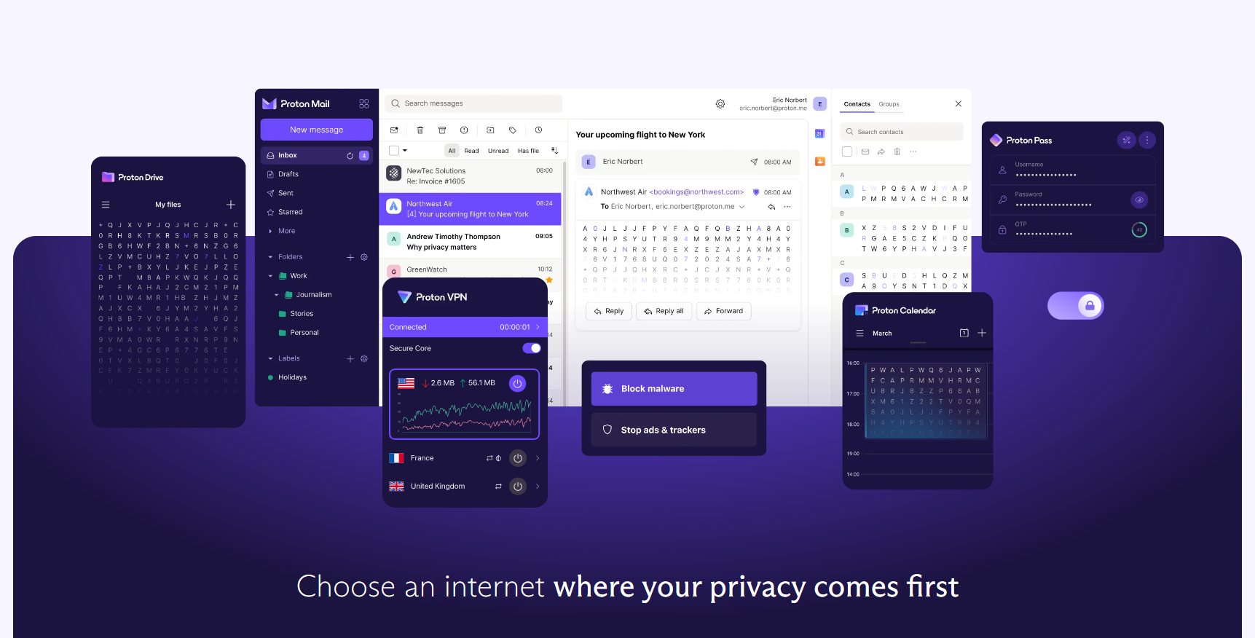

Problem Statement - Create a detailed Product Requirements Document. The PRD should have all the relevant sections called out in the course including but not limited to vision, value proposition, goals, business justification, user research, target user, key user problem, user JTBD, product strategy, solution approach, user journey, wireframes, use cases, (non) functional requirements, MVP definition, success metrics, rollout strategy, experimentation, etc.
Project - Proton is a Swiss technology company offering privacy-focused online services. It was founded in 2014 by a group of scientists who first created Proton Mail [1]. Proton is one of the many companies offering privacy-focused alternatives to Google and Microsoft, but so far are yet to make a dent in those companies’ dominance [2]. However, Proton’s products have improved a lot over the last few years. Most recently they announced Proton Docs which is a part of a larger suite of productivity and collaboration products [3]. Assuming you are the Product Head at Proton, create a winning strategy for Proton, and use it to define three key new features it should implement in one or more of its products.

Why Privacy is important?
In the last decade, privacy threats have been on increase. Some of the below statistics and examples of privacy threats will provide an idea about the existing situation and the scope of the products needs to solve the issue.
- 92% of Americans express concern about their privacy while using the Internet.¹
- Approximately 44% of data breaches involve the exposure of personal customer information, including names, emails, and passwords.
- 71% of Gen-Z users believe they wouldn’t fall for a phishing scam, even though only 44% know what “phishing” is.
- 76% of users believe companies must do more to protect their data online ⁶
- Only 3% of Americans claim to fully understand the functioning of current online privacy laws in the United States.
Types of data global online consumers are prepared to share to avoid paying for content as of February 2019:
- Merely 25% of users trust that companies handle their personal data responsibly.
- A mere 15% of individuals believe that companies utilize their personal data to enhance their lives.
Source: https://marketsplash.com/data-privacy-statistics

Examples of Privacy Threats
Data Breaches and Exfiltration
- Target Data Breach (2013): Millions of customer credit card details were compromised, highlighting the vulnerability of traditional retail systems. Privacy-focused payment solutions can offer enhanced protection through tokenization and encryption.
- Equifax Data Breach (2017): Social Security numbers, birth dates, and driver's license numbers of millions of Americans were exposed. Privacy-focused identity theft protection services can help mitigate the damage caused by such breaches.
Surveillance and Mass Data Collection
- Cambridge Analytica Scandal (2018): Millions of Facebook users' data was harvested without consent and used to influence political campaigns. Privacy-focused social media platforms prioritize user control over data sharing.
- Government Surveillance Programs (e.g., PRISM): Revelations of mass surveillance programs by governments have raised concerns about privacy. End-to-end encryption offered by privacy-focused communication apps can protect against such surveillance.

Targeted Advertising and Behavioral Profiling
- Google and Facebook Data Collection: These tech giants build extensive user profiles based on online activities to target ads. Privacy-focused browsers and ad blockers can limit data collection and reduce targeted advertising.
- Location Tracking: Many apps track user location for various purposes, including advertising. Privacy-focused operating systems and apps offer granular control over location sharing.
Identity Theft and Fraud
- Phishing Attacks: Cybercriminals often use phishing to steal personal information. Privacy-focused email providers can implement advanced anti-phishing measures.
- Online Payment Fraud: Credit card fraud remains a significant issue. Privacy-focused payment solutions can offer additional security layers, such as two-factor authentication and fraud detection.

Market and User Research
Over the past decade, the number of global internet users has experienced significant growth. In 2013, there were approximately 2.8 billion internet users worldwide, and by 2022, this number had more than doubled to over 5.5 billion. This growth was driven by the increasing availability of affordable mobile internet, especially in developing regions, and the expansion of digital infrastructure globally.
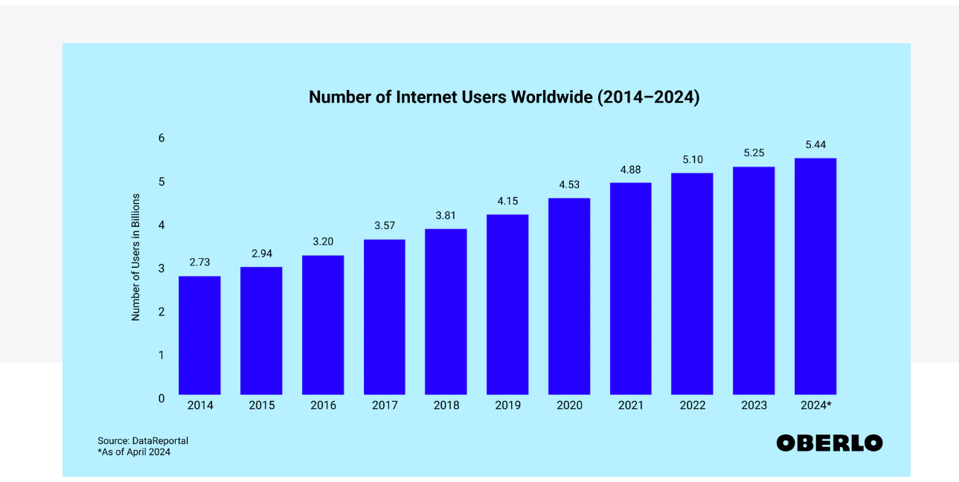

Global Growth:
- 2014-2023: The internet penetration rate worldwide increased from around 40% in 2014 to nearly 70% by 2023. This growth was most rapid in Asia, which now accounts for more than half of the global internet user base. However, regions like Africa have seen even faster growth rates in recent years, with a 39% increase in international bandwidth usage in 2022 alone.
- 2023-2030 Projections: The number of internet users is expected to reach 7 billion by 2030, with the highest growth anticipated in regions like Sub-Saharan Africa and South Asia.
TAM = consist of all the internet users which is over 5.5 billion + currently and 7 billion by 2030.
SAM = consist of the users using the internet for formal communications such as Email , video conferencing, messaging apps, and work and productivity such as Remote work, cloud storage, online collaboration. Government services, etc.
As our Project is Proton, the addressable market can be categorized as the global workforce audience using internet for work. Right now we are not addressing the educational institutes comprising the students and related area.
The estimated global workforce is approximately 3.5 billion people. And over 60% of the global workforce uses the internet for work purposes, driven largely by the adoption of digital tools, remote work, and hybrid work models.
Also, he trend towards remote and hybrid work is expected to continue, with estimates suggesting that by 2025, nearly 70% of the global workforce will regularly use the internet for work, Making it almost 2.45 billion users.
Hence our target audience is almost 30% of TAM. Here we are assuming that the 5% of TAM are the individual or small business, which are not avid about privacy concerns or are not looking actively for those solutions.
  - Identifying Serviceable Obtainable Market (SOM)
The portion of the SAM that the product can realistically capture.
Competitive Landscape:
Market Share: Given the presence of established players like Google workspace, Microsoft Office 365 , Norton VPN, a realistic market share for a non-profit org backed company, can be around 8% of the SAM.
User Acquisition: Target User Base: Capturing 8% of 2.45 billion users translates to approximately 196 million users that can be either converted or can comprise of new users.

Some noteworthy points:
Core Problems
Based on secondary research and preliminary user interviews, the core problems identified in the privacy-focused online services market include:
- Data breaches and security concerns: Users are increasingly worried about their personal data being compromised.
- Lack of trust in tech giants: There is a growing distrust in large tech companies due to data collection and privacy practices.
- Complex privacy settings: Many users find it difficult to understand and manage privacy settings.
- Limited choice of privacy-focused options: The market is still dominated by mainstream providers with limited privacy-centric alternatives.

Customer and Needs
The privacy-focused online services market encompasses a range of digital products and services that prioritize user data protection and security. This includes:
- Email services: ProtonMail, Tutanota
- Cloud storage: pCloud, Mega, googleCloud, MS azure
- Productivity suites: Proton Workspace, OnlyOffice, google workspace, MS Office
- Communication platforms: Signal, Wire, Slack,
- VPN services: ProtonVPN, NordVPN

2.1 Market Evolution
- Emerging Technologies: The integration of blockchain, AI, and zero-knowledge cryptography is reshaping the privacy landscape. These technologies offer new opportunities for secure data management and communication.
- Regulatory Changes: The implementation of data protection regulations like GDPR and CCPA has driven demand for privacy-compliant solutions. Evolving regulatory frameworks will continue to shape the market.
- Consumer Behavior: Growing digital literacy and awareness of privacy risks are driving consumer preferences towards privacy-centric products and services.

2.2 Customer Segmentation
following customer segments for Proton are proposed
- Privacy-Conscious Individuals: Tech-savvy individuals with a strong awareness of data privacy issues. They are willing to pay a premium for robust security features and prioritize user experience.
- Enterprise and Small Businesses: Organizations seeking secure and compliant communication and collaboration tools. They value data protection, reliability, and scalability.
- Government and Non-Profit Organizations: Institutions with strict data handling regulations and a need for secure, open-source solutions.

2.3 New Avenues for Proton: Addressing Immediate Needs
Proton's core value proposition of privacy and security positions it well to address a growing market demand. To differentiate itself and capture a wider audience, Proton should consider these immediate needs:

1. Enhanced User Experience and Accessibility
- Intuitive Interface: Simplify the user interface for non-tech-savvy users.
- Mobile Optimization: Ensure seamless experience across various devices and screen sizes.
- Accessibility Features: Incorporate features for users with disabilities to promote inclusivity.

2. Expanded Product Suite
- Secure File Sharing and Collaboration: Offer robust file sharing options with granular control over permissions.
- End-to-End Encrypted Video Conferencing: Provide a secure platform for video calls, meetings, and webinars.
- Secure Messaging App: Expand beyond email with a comprehensive messaging solution.

3. Strengthened Education and Awareness
- Privacy Education Resources: Offer informative content and guides on online privacy and security.
- Partnerships with Advocacy Groups: Collaborate with privacy advocacy organizations to raise awareness.
- User Onboarding and Tutorials: Provide clear guidance for new users to maximize product benefits.

4. Focus on Specific Market Segments
- Small Businesses and Enterprises: Develop tailored solutions for data protection and compliance needs.
- Healthcare and Financial Institutions: Offer specialized products for highly regulated industries.
- Education Sector: Provide secure platforms for students, teachers, and administrators.

5. Leverage Emerging Technologies
- Blockchain Integration: Explore blockchain for secure data storage and verification.
- AI for Threat Detection: Utilize AI to enhance security measures and protect against emerging threats.
- Biometric Authentication: Offer advanced authentication options for enhanced security.
By focusing on these areas, Proton can not only expand its user base but also solidify its position as a leader in the privacy-focused market.

Industry and Competitive Analysis

3.1 Industry Characteristics
The privacy-focused online services industry is characterized by:
- Rapid Growth: Driven by increasing consumer awareness of data privacy and security breaches.
- High Competition: A growing number of startups and established tech companies are entering the market.
- Regulatory Scrutiny: Stricter data protection regulations are shaping industry practices.
- Technology-Driven Innovation: Continuous advancements in encryption and security technologies are driving product development.
- Customer-Centric Focus: Building trust and loyalty is crucial for long-term success.

3.2 Competitive Analysis

Google
- Strengths: Google dominates in several areas including search engines, email (Gmail), cloud storage (Google Drive), productivity tools (Google Workspace), and communication (Google Meet). The company’s ecosystem is highly integrated, making it difficult for users to switch away.
- Weaknesses: Google's business model is heavily reliant on advertising revenue, which is driven by user data. This makes it vulnerable to growing consumer and regulatory concerns over privacy.
- Opportunities for Proton: Proton can differentiate itself by emphasizing privacy and the absence of data monetization. ProtonMail and ProtonDrive offer secure, encrypted alternatives to Gmail and Google Drive.

Microsoft
- Strengths: Microsoft’s Office 365 suite, Teams, and Azure cloud services are deeply entrenched in the enterprise market. Microsoft has a reputation for stability, security, and comprehensive enterprise solutions.
- Weaknesses: Although Microsoft has improved its stance on privacy, it still collects significant amounts of data, particularly in its consumer products.
- Opportunities for Proton: Proton can target small to medium enterprises (SMEs) and privacy-conscious users who seek secure communication and collaboration tools, free from data exploitation. ProtonDocs and ProtonCalendar can be promoted as secure alternatives to Microsoft Word and Outlook Calendar.

Slack
- Strengths: Slack is a leader in workplace communication, known for its ease of use, integration capabilities, and extensive app ecosystem.
- Weaknesses: Slack’s primary focus on communication leaves gaps in providing a full suite of productivity tools, which may force users to rely on multiple platforms.
- Opportunities for Proton: Proton can position itself as a more secure alternative for communication with ProtonMail and ProtonCalendar, especially for organizations that prioritize confidentiality in their internal communications.

Tutanota
- Strengths: Tutanota is a German-based encrypted email service that emphasizes privacy and security, similar to ProtonMail. It offers end-to-end encryption, including encrypted email subject lines, and provides features like encrypted calendars.
- Weaknesses: Tutanota has a smaller user base compared to ProtonMail and fewer integrations with third-party services. It also lacks some of the advanced features and usability that ProtonMail offers.
- Opportunities for Proton: ProtonMail can capitalize on its broader product suite, including VPN, calendar, and drive services, positioning itself as a more comprehensive solution for privacy-focused users.

Tresorit
- Strengths: Tresorit is a Swiss-based cloud storage provider known for its end-to-end encryption and zero-knowledge policies. It competes directly with ProtonDrive, offering a secure alternative to mainstream cloud storage solutions like Google Drive and Dropbox.
- Weaknesses: Tresorit is primarily focused on storage, lacking the broader suite of tools that Proton offers. Its higher price point might also deter individual users and smaller businesses.
- Opportunities for Proton: ProtonDrive can leverage its integration with ProtonMail and ProtonCalendar to offer a more seamless experience for users who want all their productivity tools under one secure, encrypted platform.

DuckDuckGo
- Strengths: DuckDuckGo is a well-known privacy-focused search engine that does not track users or personalize search results based on data. It has gained a significant following among users who value privacy and is often recommended as an alternative to Google Search.
- Weaknesses: DuckDuckGo is limited to search functionality and lacks broader privacy tools that Proton offers. Additionally, it competes directly with Startpage and Brave Search.
- Opportunities for Proton: Proton could potentially partner with DuckDuckGo to integrate privacy-focused search capabilities directly into ProtonMail or ProtonDrive, offering users an additional layer of privacy while browsing the web.

Signal
- Strengths: Signal is a leading encrypted messaging app, offering end-to-end encryption for messages and calls. It is widely recognized for its strong privacy protections and has gained popularity as a secure alternative to WhatsApp and Facebook Messenger.
- Weaknesses: Signal focuses primarily on messaging and lacks the broader suite of tools that Proton offers. It also relies on user donations and grants, which could limit its ability to scale compared to competitors with more robust funding.
- Opportunities for Proton: Proton could explore expanding its communication tools to include encrypted messaging, potentially integrating with or offering a similar service to Signal. This would allow Proton to offer a more comprehensive privacy suite that includes email, cloud storage, calendar, VPN, and secure messaging.

3.3 Market Share and User Behavior
Determining exact market share for free and paid versions can be challenging due to varying data sources and methodologies. However, general trends suggest:
- Free Tier Dominance: Most users opt for free tiers due to the perceived low cost.
- Paid Tier Conversion: A smaller percentage of users are willing to pay for premium features and increased storage.
- Google and Microsoft Dominance: While they offer limited privacy features, their extensive feature sets and integration with other services give them a significant market share.

3.4 Google and Microsoft: A Closer Look
Google Workspace and Microsoft 365 offer a vast array of features, including:
- Email: Gmail and Outlook, respectively, are dominant in the email market, offering robust features, integration with other services, and large storage capacities.
- Collaboration: Google Docs, Sheets, and Slides, and Microsoft Word, Excel, and PowerPoint are industry standards for document creation and collaboration.
- Cloud Storage: Google Drive and OneDrive provide ample storage space and integration with other services.
- Additional Services: Both suites offer a wide range of additional services, including calendars, video conferencing, and project management tools.
While these platforms prioritize user experience and feature richness, they often compromise on privacy and security.

3.5 Conclusion
Proton AG competes in a diverse field of privacy-focused technology companies. While some competitors like Google and Microsoft offer extensive ecosystems that include productivity and communication tools, they also raise significant privacy concerns that Proton can address. Other competitors, such as Tutanota, Tresorit, and Signal, offer strong privacy features but lack the comprehensive product suite that Proton has developed.

Vision and Value Proposition
4.1 Vision: Proton AG envisions a world where privacy is the default, not the exception. We are committed to empowering individuals and organizations with tools that prioritize security and privacy, ensuring that their data remains their own. Our mission is to create a comprehensive suite of online services that are secure, easy to use, and designed to protect our users from surveillance and data exploitation.
4.2 Value Proposition: Proton AG differentiates itself by offering a fully integrated, privacy-focused ecosystem that includes email (ProtonMail), cloud storage (ProtonDrive), VPN services (ProtonVPN), and productivity tools (ProtonCalendar and ProtonDocs). Our products are built on the principles of end-to-end encryption, zero-access encryption, and open-source transparency, ensuring that our users' data is secure and private. Unlike our competitors, Proton AG is headquartered in Switzerland, where stringent privacy laws offer additional protection against government surveillance and data requests.
Unique Selling Points (USPs):
- End-to-End Encryption: Proton AG offers complete end-to-end encryption across its suite of products, ensuring that only users can access their data.
- Swiss Privacy Laws: Our headquarters in Switzerland provide a legal framework that guarantees the highest level of privacy protection.
- Open-Source Software: We believe in transparency, which is why our software is open source and can be audited by anyone.
- Integrated Privacy Ecosystem: Unlike competitors who offer standalone products, Proton AG provides a seamless experience across email, storage, VPN, and productivity tools, all designed with privacy at their core.
Product Principles
- Privacy by Design: Every product we develop is designed with privacy as the primary focus. This principle ensures that user data is never accessed by Proton or third parties.
- User Empowerment: We empower our users by giving them control over their data. Whether through encrypted email, secure cloud storage, or a private VPN, users decide who can access their information.
- Transparency and Trust: We build trust with our users through transparency. By making our software open source, we allow independent audits and reviews, which reinforces our commitment to privacy and security.
- Ease of Use: Security should not come at the expense of usability. We strive to create products that are not only secure but also user-friendly, enabling more people to take control of their privacy without technical expertise.
- Global Accessibility: Privacy is a universal right, and our products are designed to be accessible to users worldwide, regardless of their technical background or financial means. This includes offering free versions of our services to ensure everyone has access to privacy.
Why These Principles Lead to Competitive Advantage: Proton AG’s commitment to privacy by design and user empowerment ensures that our products are differentiated in a market where data exploitation is the norm. By prioritizing transparency and ease of use, we build trust and loyalty among users, which is critical for long-term success. Our global accessibility approach helps us reach a broader audience, ensuring that privacy tools are available to everyone, not just the tech-savvy or wealthy. These principles create a strong foundation for competitive advantage, positioning Proton AG as the leading choice for users who value their privacy.

GTM Strategy
- Business Model:
  - Freemium Model: Proton AG operates on a freemium model, where basic services (such as ProtonMail and ProtonVPN) are free, and premium features are available through subscription plans. This model allows users to experience the benefits of privacy-focused tools at no cost, with the option to upgrade for more advanced features.
  - Subscription Plans: Premium plans offer additional storage, advanced security features, and priority customer support. These plans are tailored to both individual users and businesses, providing flexible pricing options.
- Distribution:
  - Direct-to-Consumer (DTC): Proton AG primarily uses a DTC approach, distributing its products directly through its website. This approach allows us to maintain control over the user experience and ensure that privacy standards are upheld.
  - App Stores: Our products are also available through major app stores (Google Play, Apple App Store) to reach mobile users and enhance accessibility.
- Sales Strategy:
  - Inbound Marketing: We leverage content marketing, SEO, and social media to attract privacy-conscious users who are actively seeking secure alternatives to mainstream services.
  - Partnerships and Affiliations: Proton AG partners with organizations and influencers in the privacy space to increase visibility and credibility. We also participate in tech conferences and privacy-focused events to reach our target audience.
- Branding and Marketing:
  - Privacy-First Messaging: Our marketing efforts emphasize Proton AG’s commitment to privacy and security, distinguishing us from competitors who monetize user data.
  - Educational Campaigns: We run educational campaigns to raise awareness about the importance of privacy and how our products can help protect user data.
  - Community Engagement: Proton AG engages with its community through forums, social media, and feedback loops, ensuring that we remain responsive to user needs and concerns.
- International Expansion:
  - Localized Content: To reach a global audience, we provide localized content and support in multiple languages, ensuring that users from different regions can access our services.
  - Compliance with Local Regulations: Proton AG adheres to local data protection regulations, ensuring compliance with laws such as GDPR in Europe and other privacy frameworks globally.
- Customer Support and Success:
  - Multi-Tiered Support: We offer multi-tiered customer support, with priority given to premium users. Our support team is trained to assist with privacy concerns and technical issues, ensuring a positive user experience.
  - User Onboarding: New users are guided through an onboarding process that highlights key features and best practices for maintaining privacy, helping them get the most out of our products.
By adhering to this product strategy and GTM plan, Proton AG can continue to differentiate itself in the privacy market, attract and retain users, and establish itself as the leading provider of privacy-focused digital services.

High-Level Goals and Objectives

6.1 Enhance User Privacy and Security
- Problem: In an era of increasing data breaches and digital surveillance, users are concerned about the security and privacy of their personal information online.
- Objective: Develop and enhance features that ensure user data is protected at all times, with end-to-end encryption and zero-access encryption as core principles.

6.2 Improve Accessibility and Usability
- Problem: While Proton's services are robust in terms of security, they can be complex for less tech-savvy users, limiting accessibility.
- Objective: Simplify the user interface and user experience across all products, making secure communication and data management accessible to all users, regardless of technical expertise.

6.3 Expand Cross-Platform Integration
- Problem: Users today operate across multiple devices and platforms, and require seamless synchronization of their data and communication.
- Objective: Ensure Proton's services are fully integrated across all major platforms, with consistent user experiences and functionalities, enabling users to access their secure data anytime, anywhere.

6.4 Support Regulatory Compliance
- Problem: As global privacy regulations like GDPR and CCPA evolve, users need assurance that their service providers are compliant.
- Objective: Continuously update Proton's services to ensure full compliance with global data protection regulations, providing users with peace of mind.

User Personas and Problems

7.1 Persona: The Privacy-Conscious Professional
- Demographics: Mid-career professionals in fields like law, finance, or healthcare, aged 30-50.
- Core Needs: Secure communication channels that protect sensitive client information and ensure compliance with industry regulations.
- Pain Points:
  - Complexity of Use: The current setup and management of secure communications can be cumbersome, leading to potential user errors.
  - Cross-Platform Issues: Difficulty in managing secure communications across multiple devices without compromising security.
- Detailed Problem: The Privacy-Conscious Professional often struggles with the balance between maintaining high security and ensuring ease of use. They need an intuitive platform that simplifies secure communication without requiring deep technical knowledge. Moreover, they need to seamlessly integrate Proton's services into their existing workflows across different devices, ensuring they can securely access information whether in the office, at home, or on the go.

7.2 Persona: The Digital Nomad
- Demographics: Young professionals, aged 25-35, who work remotely and travel frequently.
- Core Needs: Reliable, secure access to personal and work-related data across various international locations and networks.
- Pain Points:
  - Network Vulnerabilities: Concern over using public Wi-Fi networks and the potential risks to data security.
  - Access Issues: Difficulty in accessing certain services or websites due to regional restrictions and censorship.
- Detailed Problem: The Digital Nomad needs Proton's services to offer robust protection against network vulnerabilities, especially when using insecure public Wi-Fi. They also require consistent access to their data, regardless of their geographic location, and tools that can bypass regional censorship without compromising their security. The challenge is ensuring that these services are easy to use while traveling, with minimal setup required.

7.3 Persona: The Privacy Advocate
- Demographics: Tech-savvy individuals, aged 20-40, deeply invested in digital rights and privacy.
- Core Needs: Advanced privacy tools that allow them to protect their digital footprint and advocate for privacy rights.
- Pain Points:
  - Lack of Transparency: Frustration with services that do not provide clear information on how data is handled and protected.
  - Limited Customization: The need for more advanced customization options to tailor security settings to specific needs.
- Detailed Problem: The Privacy Advocate requires a platform that not only provides top-tier privacy features but also offers transparency and control over how their data is handled. They seek more granular control over security settings, allowing them to customize their privacy measures to fit their unique needs. Additionally, they expect Proton to lead by example in the digital privacy space, setting new standards and providing educational resources on digital rights.

